Assignment 2

Valini Rangasamy | 1796104 | Enterprise Java Beans | July 4th, 2018

# 1.A software development company is changing from a traditional SDLC to Agile. Explain methodology, benefits and how can the developers adapt to this methodology.

Agile is a method in project management that is used in the software development process. It emphasizes on incremental delivery, team collaboration as well as on continuous planning and learning. This approach is very beneficial especially when dealing with the unpredictability of constructing a software from start to finish and changing business needs. It uses incremental work sequences called sprints and make the tasks of building a software more manageable and efficient. It helps to foster teamwork and better collaboration and it gives them achievable goals they want to achieve in order to have a working software. It improves customer satisfaction as it is more adaptable and open to changes. Launching products and making updates are also faster with agile. This is because developers work on a module in short period of time, also called a sprint. Each sprint lasts two to three weeks and during this time, feedbacks are collected from users and any problems are identified. These are used to develop the requirements for the next sprint until a working product is built.

# 2. What is MVC and explain its architecture. How it works and benefits project? Find advantages and disadvantages. Include diagrams for your answer.

MVC stands for Model-View-Controller and is a software architecture pattern or a way to structure your web applications. It separates a software application into three parts or responsibilities; it separates the data access layer, the business logic code and the graphical user interface that enables the user to interact with the application. These three parts are the Model, the View and the Controller.

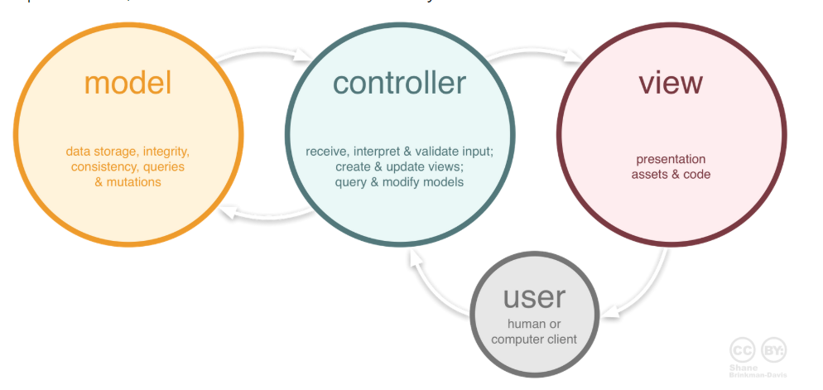

1 . The model represents the logical structure of data in the app. It is responsible to manage the data of the application and responds to request from the controller whenever there is any change in the model’s data. It retrieves and stores model state in a database.

2. The View represents all the User Interface logic of the application and it presents the data to the user whenever asked for. It renders the data that it receives from the controller and determines how the data in the model is going to be displayed to the user. The view can range from charts, texts and diagrams.

3. The Controller handles user interaction with the model and select a view to render to the user. For example, the controller handles query-string values, and passes these values to the model, which in turn might use these values to query the database.

This separation of tasks makes it easier for developers as each layer can be developed separately. As project gets bigger, it is then easy to control, develop, debug or add features to all of the layers separately.

Another benefit of using MVC framework in projects is that it hides the data layer from the user. Only the controller can get access to the data layer and users cannot access data directly. This feature helps developers to create roles of users such as admin and guest and thus they control the data access by users and the databases are much more secure.

**Advantages:**

1. Faster development process where tasks for building the app can be separated between developers, programming the views does not depend on the models.
2. Modification does not affect the entire model because they are all separate.
3. Changes to the styles and graphical presentation of the same data is easier
4. It is easier to maintain and understand a large complex project that have several people working on.
5. Easier to find bugs and to update part of the code without affecting other parts.

**Disadvantages**

1. Requires a team of programmers
2. It requires the knowledge of multiple technologies
3. Can become complex

## 3. What is JSP? What are the different tags in JSP? What are the benefits of using JSP in a project? Compare JSP vs HTML

JSP also known as Java Server Pages is a technology that helps towards the creation of dynamic and platform independent web applications using Java and Java Servlets. Requests are made to Java Servlet that can perform the logic and the result is rendered to Java Server Pages that acts like the user interface for the Java web application. Program developers can embed jsp codes with html code using the JSP tags. These special tags with Java code can be inserted in HTML pages without affecting the HTML codes. They can also be used for various purposes like sending data from one page to another, retrieving data from the database, getting data from forms on submit and much more.

These tags can be

1. Scriptlet tags - <% %> to execute java source code in JSP.
2. Declaration tag - <%! %> to declare a variable in JSP.
3. Directive tag - <%@ %> to import classes in JSP.
4. Expression tag - <%= %> to write the output of a response.

**The advantages of JSP are:**

1. Can be easily embedded in HTML codes to create dynamic pages
2. It is easy to maintain, make changes without the need to recompile and redeploy
3. It can receive request directly without any Servlet
4. Allows us to use separate presentation logic (html code) from Java code (business logic)
5. Has Java’s power of portability and can operate on any platform, so that web application can work anywhere.
6. JSP are designed on top of the Java Servlets API and thus they have access to all the powerful Java APIs such as JDBC, JNDI, EJB, JAXP, etc.

**Differences between HTML and JSP are:**

1. HTML generate static web content whereas JSP can generate dynamic web content
2. HTML is a client-side technology whereas JSP is a server-side technology
3. HTML pages cannot have java code in them whereas JSP pages allows java code embedded with HTML
4. HTML need an HTML Interpreter where JSP needs a JSP container to execute jsp code.

## 4.What is Maven? Add screenshots of step by step tutorial of creating a Maven Project in eclipse. Copy and paste pom.xml and explain its code.

Maven is a powerful project management tool that is based on POM (project object model). It is used for projects build, dependency and documentation.

Steps to creating a Maven Project

1.Create New Maven Project

1.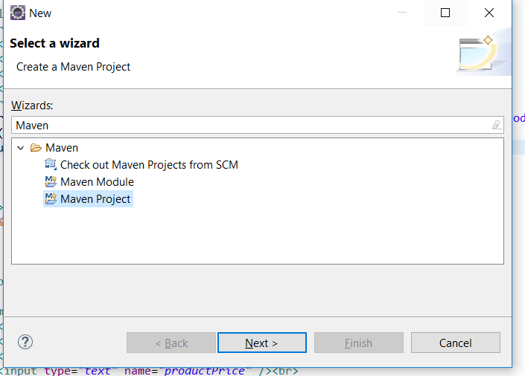

2.Choose maven-archetype-webapp

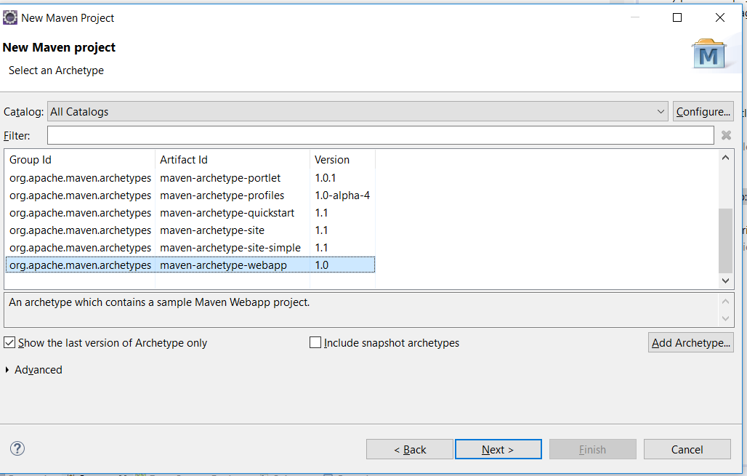

3.Add a GroupID and Artifact ID like a project name.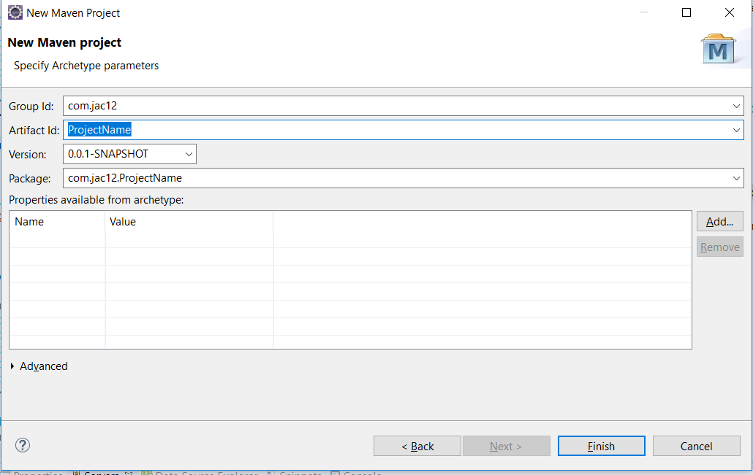  
4.Finish creating and add a folder called Java to the main. As classes and Servlets are created, they are s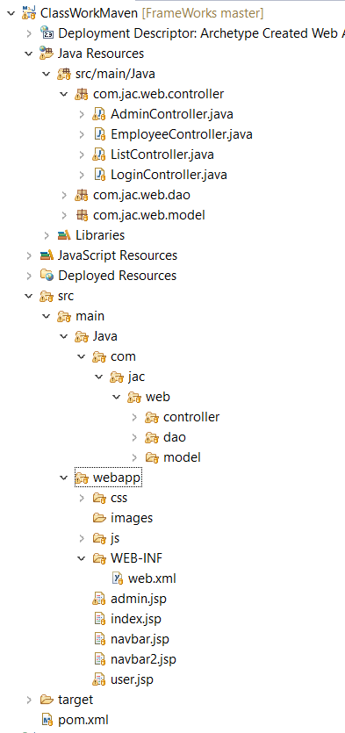aved under different packages just like in the picture above.

5. Add the jar dependencies that you require like Servlet jar, database connection jar, bootstrap jar….

Pom stands for Project Object Model. Pom.xml files contain information about project and configuration details used by Maven to build the project. All POM files require the project element and three mandatory fields: groupId, artifactId, version.

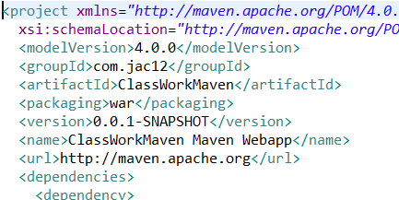

The pom xml file below also has dependencies for mysql and javax-servlet that have been copied and pasted from maven repository website. There is no need to download the jar file for mysql and java servlet api separately and copy paste in lib folder. It makes it very easy to just start coding and saves time.

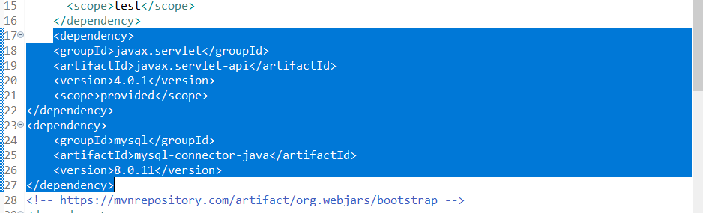

## 5 What are the benefits of using Spring over J2EE applications? Also, find some benefits of having Hibernate in a project

There are various benefits of using Spring Open Source Framework over the J2EE framework. While J2EE has a heavy weight Enterprise Architecture that is dependent on a J2EE container to run, Spring framework offers a simplified process to build large J2EE applications and they do not depend on a J2EE container to run. Spring framework is easy to be deployed on computers with limited memory and CPU resources because of its light weight IoC Containers compared to the EJB containers. It is also very easy to develop small and large applications in Spring because it based on Inversion of Control (loosely coupled models) that removes dependency in the programming code whereas in J2EE are not modular and are tightly integrated and rigid which makes it hard to make changes, implement and test.

Hibernate is an open source ORM (Object to Relational Mapping) tool that is used in applications for handling data. It is a programming technique for converting data between relational databases and object-oriented programming languages such as Java. It sits between the Java Objects and the Relational database and takes care of the mapping of Java classes to the database tables. Hence it makes it easy for developers to make data queries and other common data persistence related programming tasks.

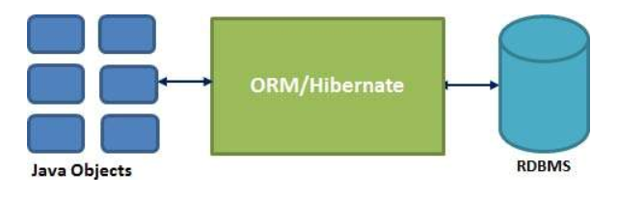

If there are any changes to be made to the database tables in the project, only the XML file properties must be changed and thus it makes application development process much faster. Hibernate also supports most of the major Relational databases.

## References

1. <https://linchpinseo.com/the-agile-method/>
2. <https://www.infoworld.com/article/3237508/agile-development/what-is-agile-methodology-modern-software-development-explained.html>
3. <https://www.randstad.ca/workforce360-trends/archives/what-is-the-agile-methodology_555/>
4. https://www.codeproject.com/Articles/879896/Programming-in-Java-using-the-MVC-Architecture
5. <https://www.interserver.net/tips/kb/mvc-advantages-disadvantages-mvc/>
6. <https://codebots.com/app-development/how-codebots-works-mvc-architecture>
7. <https://www.sitesbay.com/jsp/jsp-and-html>
8. https://www.dineshonjava.com/hibernate-3-on-baby-steps/
9. https://www.tutorialspoint.com/hibernate/index.htm